16-BIT ADDITION

EXP NO: 1

AIM: To write an assembly language program to implement 16-bit addition using 8086 processor.

ALGORITHM:

1) Start the program by loading the first data into the accumulator.

2) Move the data to a register.

3) Get the second data and load it into the accumulator.

4) Add the two register contents.

5) Check for carry.

6) Store the value of sum and carry in the memory location.

7) Halt.

Program:

MOV AX, 0054

MOV BX, 0050

ADD AX,BX

HLT

Input:

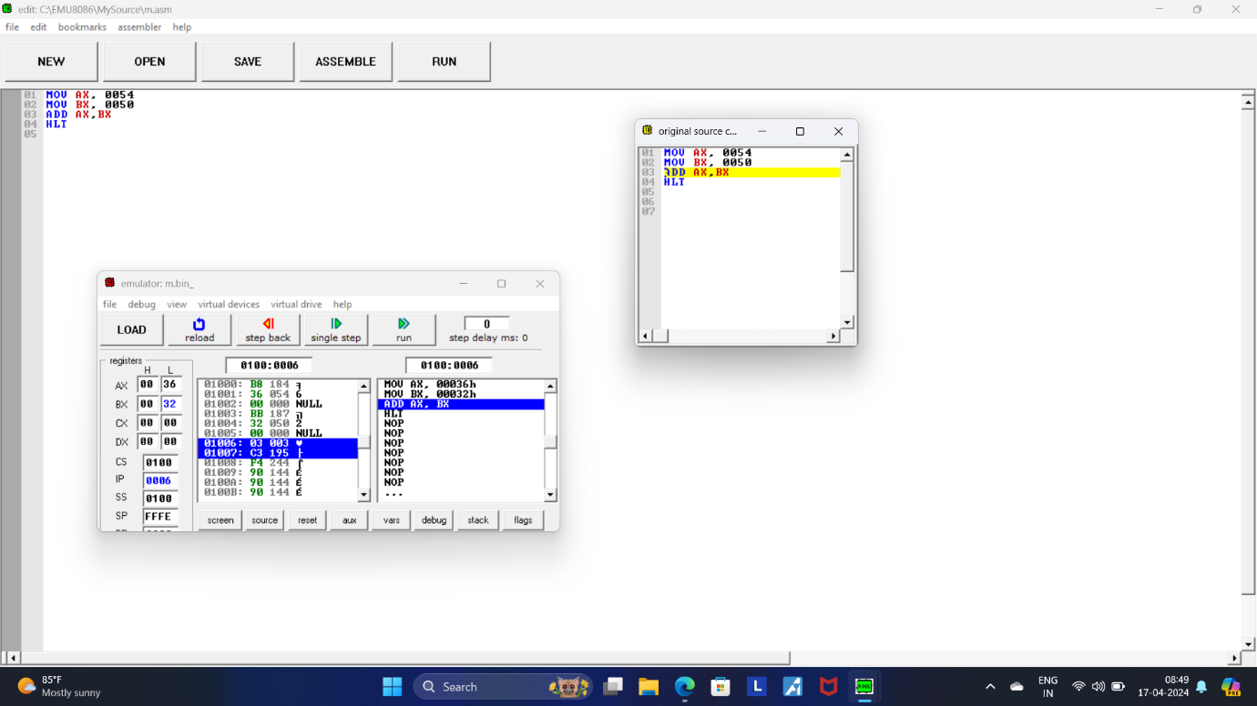

Output:

